Chemistry 141 Name
Martin Larter
Exam 2a October 14, 2015

Multiple Choice (30 points)

Page 5 (16 points)

Page 6 (18 points)

Page 7 (12 points)

Page 8 (16 points)

Page 9 (14 points)

Total (106 points)
All work must be shown to receive credit. Give all answers to the correct number of significant figures

Chemistry Formulas

Kinetic energy = ½ mv²
w = -PΔV
P_{total} = P₁+P₂+P₃+…
u = (3RT/MW)^{½}
ΔG = ΔH - TΔS
PV = nRT
Rate ∝ (MW)^{-½}
P₁=X₁*P_{total}
C = q/ΔT
P_{total} = P₁ + P₂ + P₃ + …
M = mol/L
K = ºC + 273.16
w=dxF
E = mc²
$$E=nhν$$
$$c=λν$$
M₁V₁ = M₂V₂
P_{total} = P₁ + P₂ + P₃ + …
M = mol/L
$$\frac{{Rate}_{1}}{{Rate}_{2}}=\sqrt{\frac{{MW}_{2}}{{MW}_{1}}}$$
$$\left(P+\frac{n^{2}a}{V^{2}}\right)\left(V-nb\right)=nRT$$
$$λ_{deBroglie}=\frac{h}{mv}$$

Constants

Avogadro’s number = 6.022 x 10²³ /mol
Density of H₂O(l) = 1.00 g/mL
h = 6.626 x 10⁻³⁴ J sec
c= 2.9979 x 10⁸ m/sec
e = 1.602 x 10⁻¹⁹ C
K = ºC + 273.16
1 kcal = 4.184 kJ
R = 0.0821 L atm/mol K = 62.4 L torr/mol K = 8.31 kJ/mol K
760 torr = 760 mm Hg = 1.00 atm = 101 kPa = 14.6 psi = 30 in Hg

Heats of formation
H₂O(g) -241.8 kJ/mol
H₂O(l) -285.8 kJ/mol
CH₃OH(l) -238.7 kJ/mol
CH₃OH(g) -200.7 kJ/mol

Grossmont College
Periodic Table
IA |  |  |  |  |  |  |  |  |  |  |  |  |  |  |  |  | VIIA | NOBLE GASES
1  H  1.008 | IIA |  |  |  |  |  |  |  |  |  |  |  | IIIA | IVA | VA | VIA | 1  H  1.008 | 2  He  4.002
3  Li  6.941 | 4  Be  9.012 |  |  |  |  |  |  |  |  |  |  |  | 5  B  10.81 | 6  C  12.01 | 7  N  14.01 | 8  O  16.00 | 9  F  19.00 | 10  Ne  20.18
11  Na  23.00 | 12  Mg  24.30 | IIIB | IVB | VB | VIB | VIIB | VIII VIII VIII |  |  |  | IB | IIB | 13  Al  27.00 | 14  Si  28.09 | 15  P  30.97 | 16  S  32.06 | 17  Cl  35.45 | 18  Ar  39.95
19  K  39.10 | 20  Ca  40.08 | 21  Sc  44.96 | 22  Ti  47.90 | 23  V  50.94 | 24  Cr  52.00 | 25  Mn  54.94 | 26  Fe  55.85 | 27  Co  58.93 | 28  Ni  58.70 |  | 29  Cu  63.55 | 30  Zn  65.38 | 31  Ga  69.72 | 32  Ge  72.59 | 33  As  74.92 | 34  Se  78.96 | 35  Br  79.90 | 36  Kr  83.80
37  Rb  85.47 | 38  Sr  87.62 | 39  Y  88.91 | 40  Zr  91.22 | 41  Nb  92.91 | 42  Mo  95.94 | 43  Tc  (99) | 44  Ru  101.1 | 45  Rh  102.9 | 46  Pd  106.4 | 47  Ag  107.9 |  | 48  Cd  112.4 | 49  In  114.8 | 50  Sn  118.7 | 51  Sb  121.8 | 52  Te  127.6 | 53  I  126.9 | 54  Xe  131.3
55  Cs  132.9 | 56  Ba  137.3 | 57  La  138.9 | 72  Hf  178.5 | 73  Ta  180.9 | 74  W  183.9 | 75  Re  186.2 | 76  Os  190.2 | 77  Ir  192.2 | 78  Pt  195.1 | 79  Au  197.0 |  | 80  Hg  200.6 | 81  Tl  204.4 | 82  Pb  207.2 | 83  Bi  209.0 | 84  Po  (209) | 85  At  (210) | 86  Rn  (222)
87  Fr  (223) | 88  Ra  226.0 | 89  Ac  227.0 | 104  Rf  (261) | 105  Db  (262) | 106  Sg  (263) | 107  Bh  (262) | 108  Hs  (265) | 109  Mt  (266) | 110  ??  (269)

58  Ce  140.1 | 59  Pr  140.9 | 60  Nd  144.2 | 61  Pm  (147) | 62  Sm  150.4 | 63  Eu  152.0 | 64  Gd  157.3 | 65  Tb  158.9 | 66  Dy  162.5 | 67  Ho  164.9 | 68  Er  167.3 | 69  Tm  168.9 | 70  Yb  173.0 | 71  Lu  175.0
90  Th  232.0 | 91  Pa  231.0 | 92  U  238.0 | 93  Np  (237) | 94  Pu  (244) | 95  Am  (243) | 96  Cm  (247) | 97  Bk  (247) | 98  Cf  (251) | 99  Es  (252) | 100  Fm  (257) | 101  Md  (258) | 102  No  (259) | 103  Lr  (260)

Lanthanide series

Actinide series

Multiple Choice (30 points) – Give the best answer for each of the following questions.

- Thermochemistry is the study of how ________ is produced and consumed during chemical reactions.

  - kinetic energy
  - work
  - temperature
  - potential energy
  - energy

- From year to year, the water level in a lake varies, as shown below. At which time is the potential energy of the water behind the dam greatest?

- The following diagrams illustrate the flow of energy (q) and work (w) in different processes. Which one is definitely an exothermic process?

  - 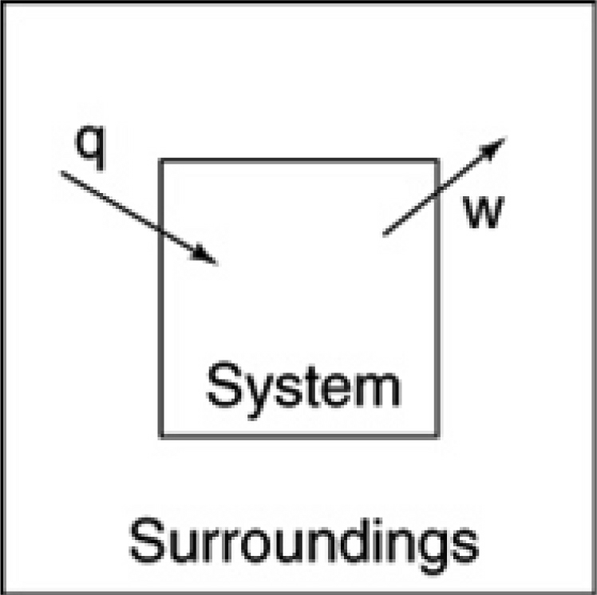
  - 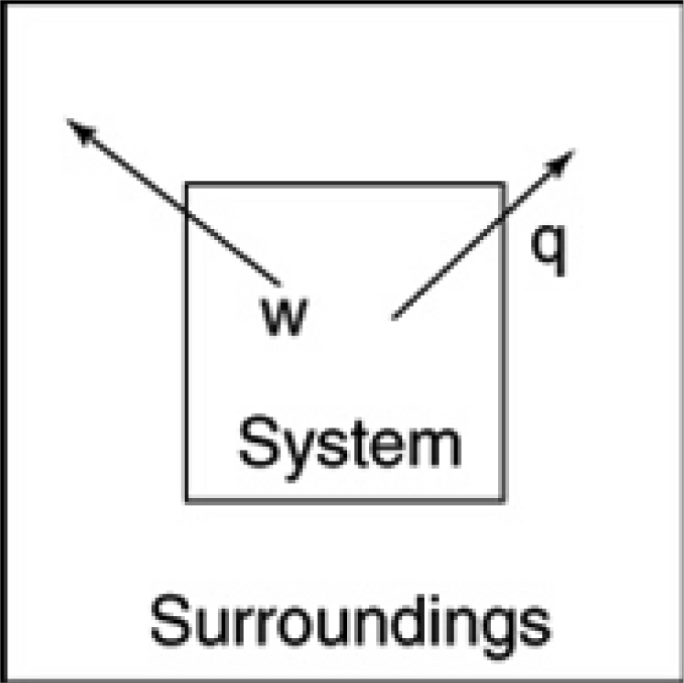

  - 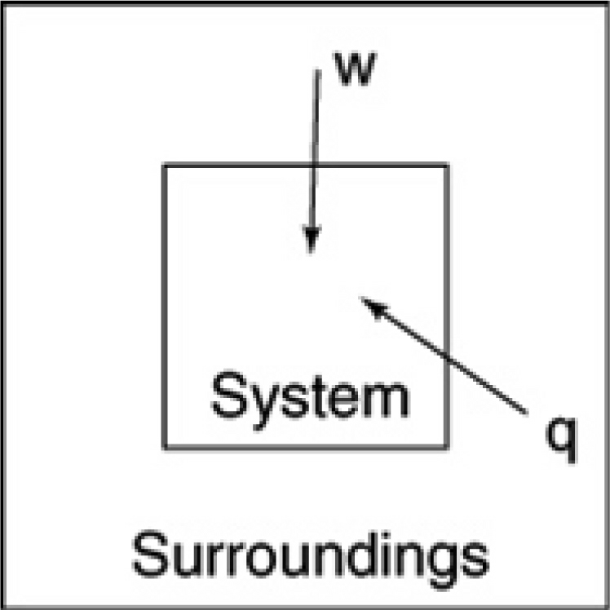
  - 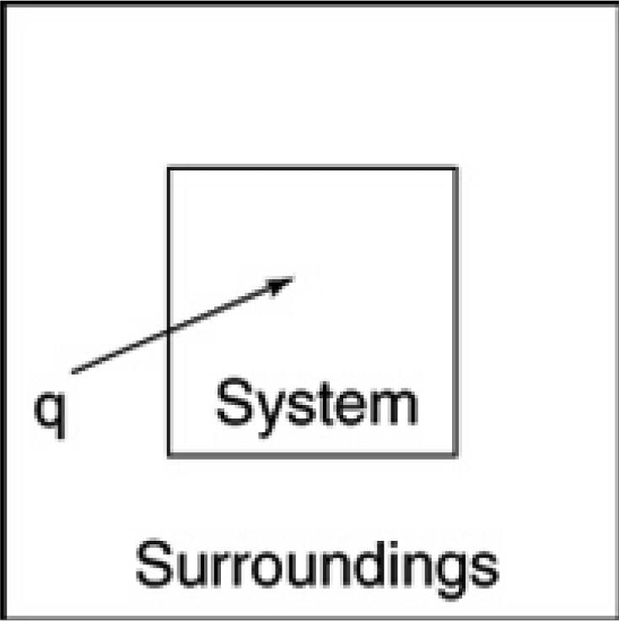

- The best definition of the enthalpy change is ________
  - the energy that is transferred into or out of a system because of a temperature difference when the pressure is constant and only PV work is done.
  - the change in internal energy of a system when the pressure is constant.
  - the change in internal energy of a system when the volume is constant.
  - the energy that is transferred into or out of a system when the pressure is constant and no work is done.
  - the change in internal energy of a system when the pressure is constant and no work is done.

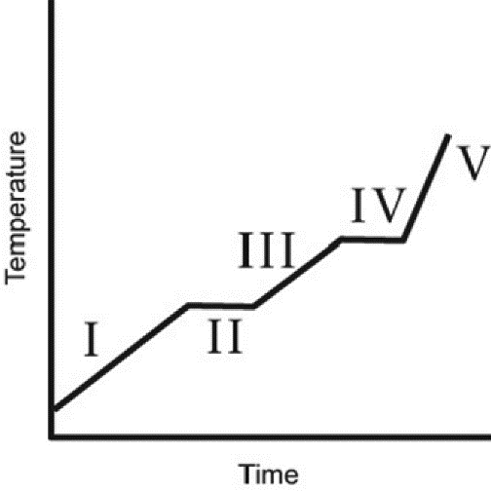
- The heating curve for a substance is shown below. The substance initially is a solid. It then becomes a liquid and a gas. Which of the line segments (I–V) represents the solid to liquid phase transition?

  - I
  - II
  - III
  - IV
  - V

- You hold a 50 g sphere of copper in one hand and a 25 g sphere of aluminum in the other hand. If both absorb energy at the same rate, which will come to your body temperature first and why? The specific heat capacities are 0.4 J/(g ⋅ °C) for copper and 0.9 J/(g ⋅ °C) for aluminum.
  - copper, because the specific heat is smaller
  - aluminum, because the specific heat is larger
  - aluminum, because the mass is smaller
  - copper, because the heat capacity is smaller
  - Both reach body temperature at the same time because they absorb energy at the same rate.

- Which statement about the properties of a gas is not correct?
  - Unlike a solid or a liquid, gases expand to occupy the entire volume of their container.
  - When the temperature is changed, the volume of gas changes much more than the volume of a solid or liquid.
  - Different gases are completely miscible with each other.
  - The density of a gas typically is much larger than the density of a solid or liquid.
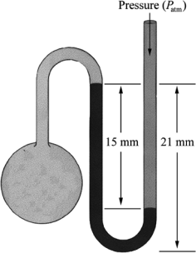
  - When the pressure is changed, the volume of a gas changes much more than the volume of a solid or liquid.

- What is the pressure in the gas bulb connected to the mercury manometer shown in the diagram if the ambient pressure is 750 torr? The heights labeled in the diagram are 15 mm and 21 mm.

  - 756 torr
  - 765 torr
  - 771 torr
  - 735 torr
  - 729 torr

- A soft drink rises in a straw when you suck on the straw because ________
  - the vacuum pulls the liquid up the straw.
  - capillary forces attract the liquid to the walls of the straw.
  - the air pressure inside the straw is less than the air pressure outside the straw.
  - the air pressure inside the straw is greater than the air pressure outside the straw.
  - the liquid level inside the straw is pushed up by the liquid level outside the straw.

- Which of the following graphs shows the correct relationship between the pressure and temperature of an ideal gas in a given volume? Note the origin corresponds to P = 0 atm and T = 0 K.

  - 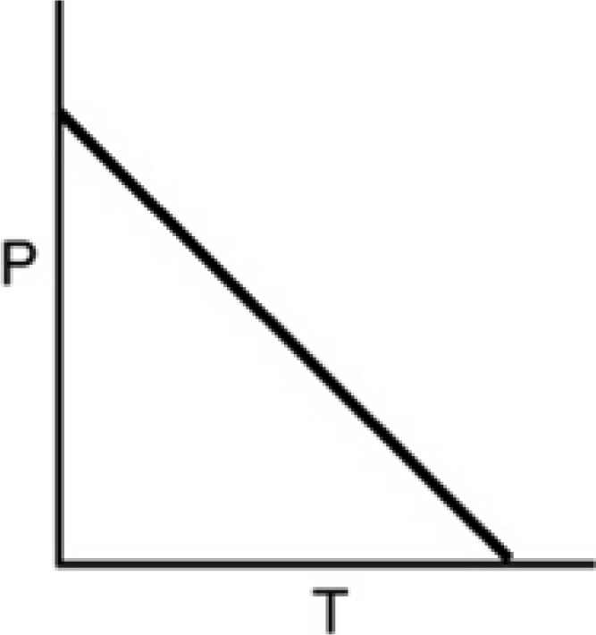
  - 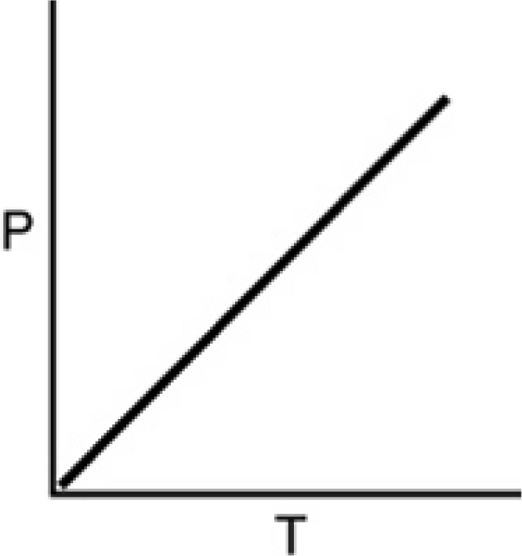
  - 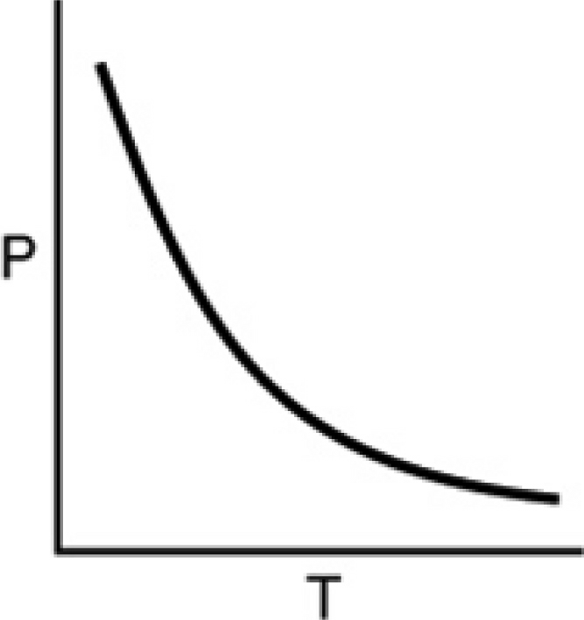

  - 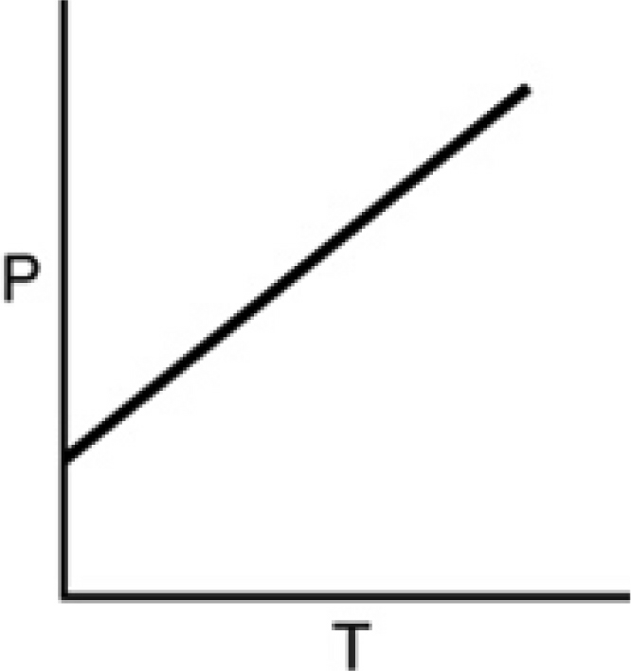

- Which of the following is unimportant when using the ideal gas law?
  - The chemical identity of the gas sample.
  - The temperature of the gas sample.
  - The pressure of the gas sample.
  - The volume of the container holding the gas sample.
  - The amount of gas.

- Four containers, each with the same volume and at the same temperature, are shown in the following diagrams. Which container is at the highest pressure?

  - 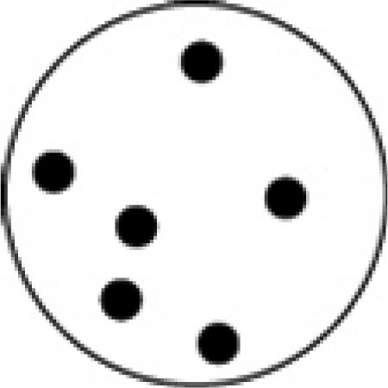
  - 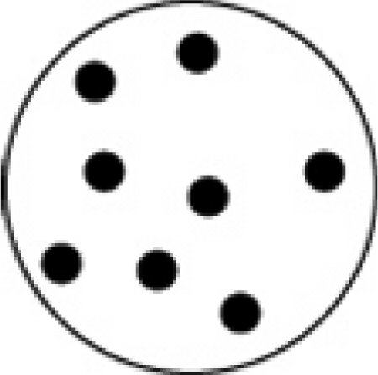

- An unknown gas held in a 25.0 mL flask at 45°F exerts a pressure of 25 mTorr. Using this information with the ideal gas law, it is possible to determine ________
  - the mass of the gas in the container.
  - the identity of the gas in the container.
  - the number of molecules of the gas in the container.
  - the molecular geometry of the gas in the container.
  - nothing more about the gas.

- Which one of the following gases could most easily be differentiated from propane (CH₃CH₂CH₃) on the basis of density when compared at the same temperature and pressure?

  - CO₂
  - F₂
  - N₂O
  - CH₂CH—CH₃
  - NO₂

- The partial pressure of a gas is ________
  - the pressure the gas exerts when pure.
  - the same as the vapor pressure of the gas.
  - the pressure due to the gas in a mixture.
  - the total pressure of a mixture of gases.
  - the pressure exerted by one molecule of the gas.

- Which of the following figures is the most accurate representation of a gas sample? The arrows show the velocities of individual molecules.

  - 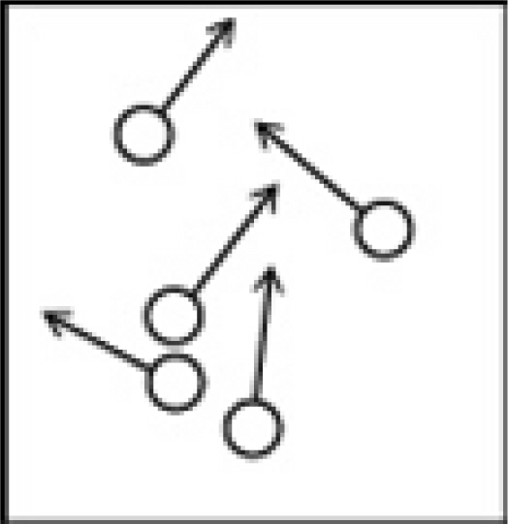
  - 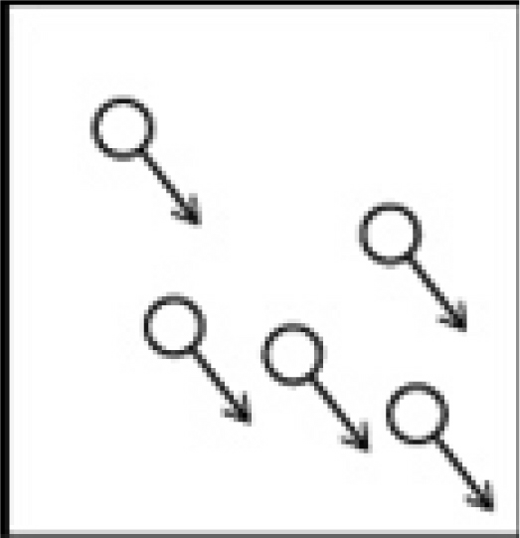
  - 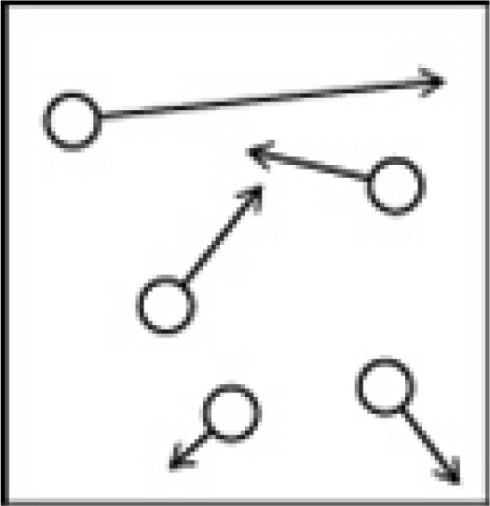
  - 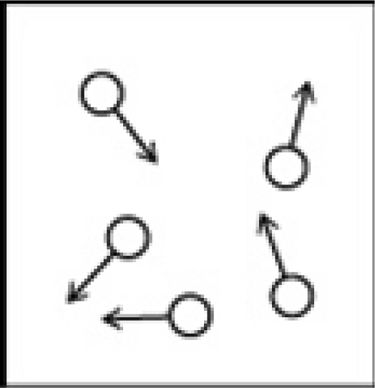

- Which one of the following statements is not correct?
In a sample of air at a given temperature ________
  - the nitrogen and oxygen molecules have the same average kinetic energy.
  - the nitrogen and oxygen molecules have the same average speed.
  - some nitrogen molecules are moving slower than some oxygen molecules.
  - some nitrogen molecules are moving faster than some oxygen molecules.
  - all the molecules are moving.

- Which one of the following statements is not correct?
  - An increase in temperature causes an increase in gas pressure because the frequency of molecules colliding with the walls of the container increases.
  - An increase in temperature causes an increase in gas pressure because the average force of molecules colliding with the walls of the container increases.
  - All gases behave like ideal gases at sufficiently low pressures and high temperatures.
  - The PV/nRT ratio for real gases can be greater than 1 because of the attractive forces between molecules.
  - Real gases deviate from ideal gases because of the finite size of the molecules and the attractive and repulsive interactions between molecules.

- Which one of the following statements about the properties of gases is not correct?
  - At low temperatures, the attractive forces between molecules cause a real gas to deviate from ideal gas behavior.
  - At high pressures, the finite size of the molecules causes a real gas to deviate from ideal gas behavior.
  - The ratio PV/RT = 1 for one mole of an ideal gas.
  - The ratio PV/nRT < 1 because of repulsive interactions between the molecules.
  - The ratio PV/nRT > 1 because of the finite size of the molecules.

Problems

- ( points) A 1.91 g sample of octane, the principle component of gasoline is burned in a calorimeter. The calorimeter is filled with 200.0 g of water at 35.0ºC and the calorimeter has a heat capacity of 48.2 J/ºC. If 15.3 g of water are evaporated from the calorimeter, what is the molar heat of reaction of the octane (C₈H₁₈)?

- ( points) Reactions of gaseous ClF with F₂ yields ClF₃, an important fluorinating agent.
ClF(g) + F₂(g) ClF₃(l)
Use the following thermochemical equations to calculate the ΔH_{rxn} for this reaction
2 ClF(g) + O₂(g) Cl₂O(g) + OF₂(g) ΔH = 167.5 kJ
2 F₂(g) + O₂(g) 2 OF₂(g) ΔH = -43.5 kJ
2 ClF₃(l) + 2 O₂(g) Cl₂O(g) + 3OF₂(g) ΔH = 394.1 kJ

- ( points) When gasoline burns in a car engine, the heat released causes the products CO₂ and H₂O to expand, which pushes the pistons outward. Excess heat is removed by the car’s cooling system. If the expanding gases do 372 J of work on the pistons and the system loses 585 J to the surroundings as heat, calculate the change in energy (ΔE) in kcal.

- ( points) The standard enthalpy of formation of NH₃ is -46.1 kJ/mol. What is the ΔH_{rxn} for the reaction 2 NH₃(g) N₂(g) + 3 H₂(g)?

ΔH_{formation}
½ N₂(g) + ³/₂ H₂(g) NH₃(g) ΔH_{for} = -46.1 kJ/mol

- (6 points) A bicycle racer inflates his tires to 8.42 atm on a warm autumn afternoon when the temperature is 28.2ºC. By morning, the temperature has dropped to 7.6ºC. What is the pressure in the tires if we assume that the volume of the tire does not change significantly?

- (6 points) You have just synthesized a new gaseous compound and check its density. You find that at a temperature of 23ºC and a pressure of 3.18 atm, the density is 37.1 g/L. What is the molar mass of this new substance?

- ( points) Methanol is toxic because it is metabolized in a two-step process in vivo to formic acid (HCOOH). Consider the following overall reaction under standard conditions:
O₂(g) + 2 CH₃OH(l) 2 HCOOH(l) + 2 H₂O(l) + 1019.6 kJ
  - Is this reaction endothermic or exothermic?

  - What is the value of ΔH_{rxn} for this reaction?

  - How much heat would be released or absorbed if 75.0 g of methanol (CH₃OH) were metabolized in this reaction? (Tell me if it is released or absorbed!)

  - Calculate the heat of formation of formaldehyde as a liquid using data from the front of the exam.

- ( points) Nitrogen can be produced from the reaction of sodium metal and potassium nitrate.
10 Na(s) + 2 KNO₃(s) K₂O(s) + 5 Na₂O(s) + N₂(g)
How many grams of sodium metal are required to make 145.0 L of nitrogen gas at a 3.25 atm and 290 K?

- ( points) A flask contains ammonia and an unknown acid HX. If the two gases are allowed to effuse out of a container, the acid effuses at a rate of 4.50 mol/hr and the ammonia effuses at a rate of 9.81 mol/hr. What is the identity of the element X?

- ( points) Consider that you have three containers of a gas at the following conditions.
Container A 375 mL O₂ at 45ºC and 1.00 atm pressure
Container B 500.0 mL N₂ at 55ºC and 2.00 atm pressure
Container C 125.0 mL H₂ at 55ºC and 6.00 atm pressure

  - Which container(s) have the highest kinetic energy and why?

  - Which container has molecules with the highest average velocity?

